UNITED STATES ENVIRONMENTAL PROTECTION AGENCY
Region I — New England
5 Post Office Square, Suite 100
Boston, MA 02109-3912
September 22, 2021

Honorable Susan L. Biro
Chief, Administrative Law Judge (1900c) U.S. Environmental Protection Agency
1200 Pennsylvania Avenue, NW
Washington, DC 20460
Re: In the Matter of A Plus Truck Sales, Inc.
Docket No. CAA-01-2021-0077
Dear Judge Biro:
Pursuant to 40 C.F.R. 22.21 (a) of the Consolidated Rules of Practice, I am transmitting a copy of the Complaint and Notice of Opportunity for Hearing in the above captioned matter along with Respondent's Answer and Request for Hearing. Please assign an Administrative Law Judge to serve as Presiding Officer.
Sincerely,

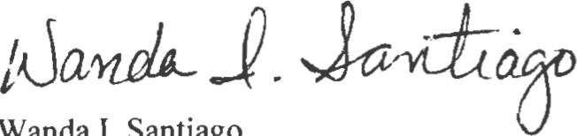
Paralegal/Regional Hearing Clerk
cc: Counsel for Respondent
Leonard I. Sharon, Esq.
95 Park Street, Suite 512
PO Box 862
Lewiston, ME 04240

Counsel for Complainant:
Tahani Rivers
Enforcement Counsel
Office of Environmental Stewardship
U.S. Environmental Protection Agency, Region I 5 Post Office Square, Suite 100 (Mail Code OES 04-3)
Boston, MA 02109-3912

